//CS4370

//Parallel Programming for Many-Core GPUs

//Avery Colley

//Meilin Liu

//12/11/24

//Programming Assignment #3 - Work Efficient Parallel Reduction and Work Efficient Parallel Prefix Sum

//Compiling command: nvcc Colley_Project3Task1.cu -o sum

//Compiling command: nvcc Colley_Project3Task2.cu -o scan

Report:

The program for task 1 has all the functionalities needed to run using an input array of size up to 1048576. The program for task 2 has all the functionalities needed to run using an input array of size up to 2048.

Parallel Reduction with input array size of 1048576: 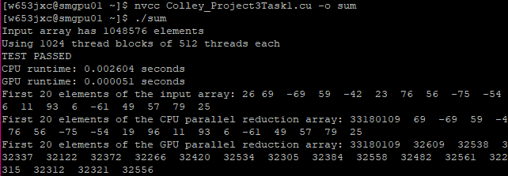

Parallel Scan with input array size of 2048:

